Alexander Baldree
07/01/26
Module 5.3 & 6.3 Project Part 1
CSD430

GitHub Link:
https://github.com/Panda-Alex21687/CSD430

Project Folder:
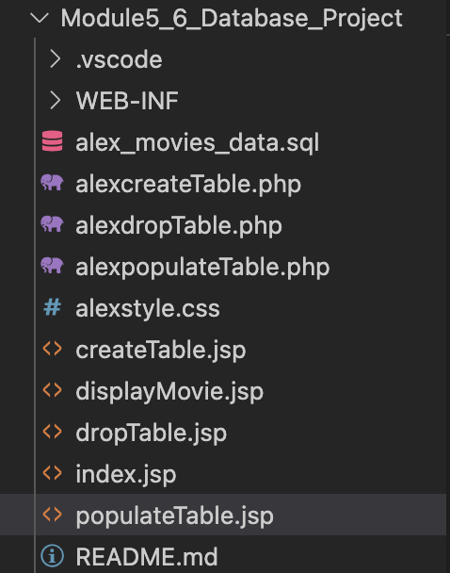
MySQL Permissions for Java access:
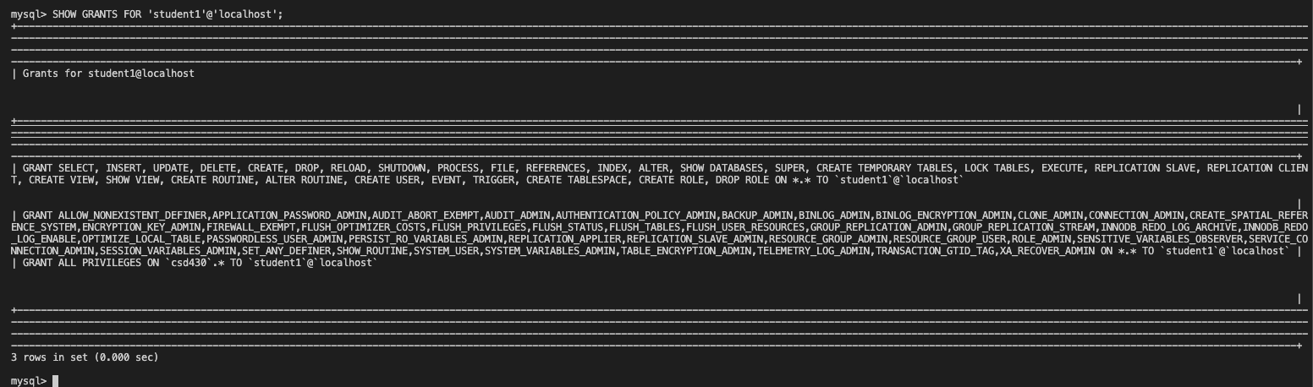
Database and Table Structure:
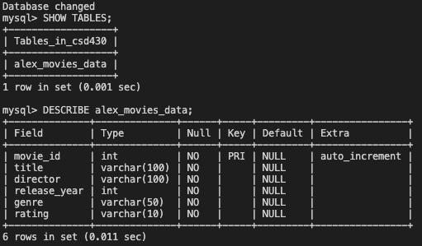

Table records:
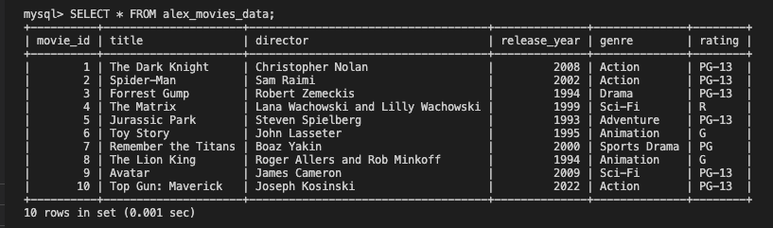

JavaBean compiled:
Tomcat running:
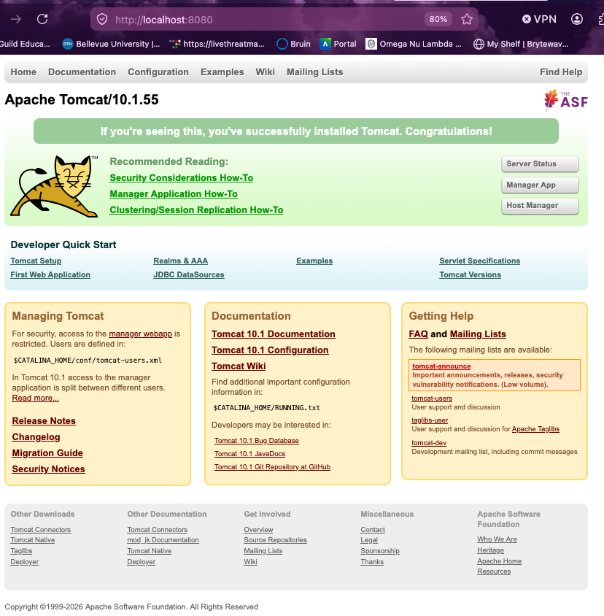

JavaBean create table:
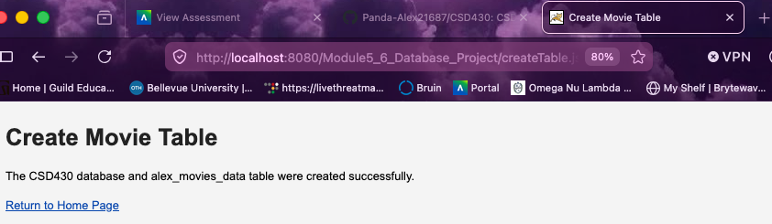

JavaBean populate table:
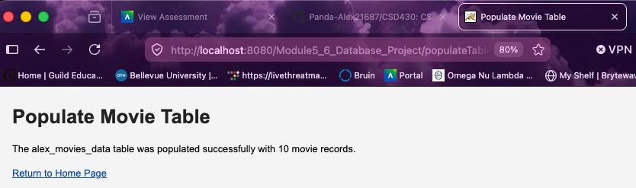

Main Dropdown JSP:
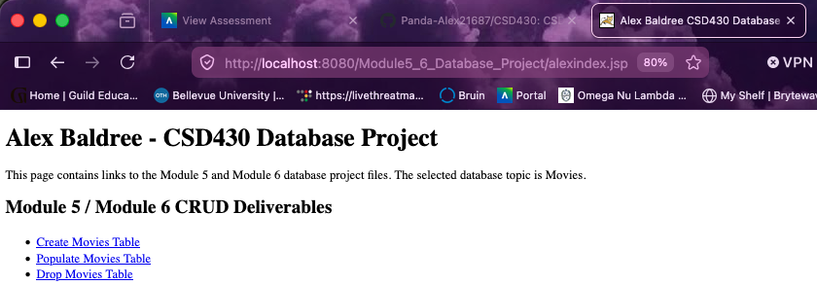

Dropdown opened:
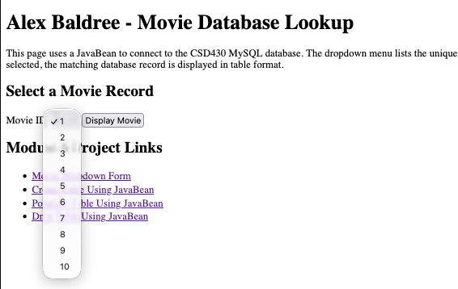

Selected record displayed:
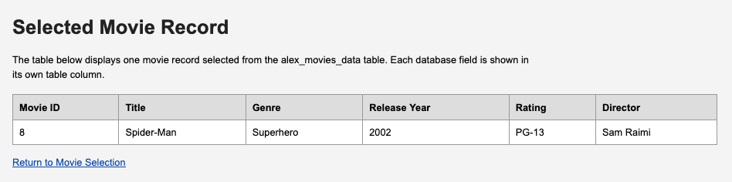

Drop Table page:
